AccessPointe Quick Training Guide
UT-UNIV OF UTAH

Product Search and Cart Transfer
Follow these steps to search for products, add them to cart and transfer the cart back into Ariba.
- After you punchin to En Pointe catalog, type in your keyword (Mfg part#, Part name, Part description etc.) in the search box to search for desired products
Type in a keyword here to search for desired products
- Add Product to your shopping cart by clicking on Add to Cart button. Once part is added to the cart, then click on View cart option as shown in the screenshot below to view the items added to the cart.

- On Shopping cart, if you want you can change the quantity of the line item as well and hit “Update”. Once done, please click on “Transfer Cart” option to transfer the cart items back into your procurement system for ordering.

How to Search an En Pointe Quote
Please follow these steps to find an En Pointe quote.
- Please click on “Document Search” option available under “My AccessPointe” dropdown
- On the document search page, please type in the En Pointe Quote # in the keyword box, then uncheck the date range and hit search which would pull the quote for you
- A click on the quote # would pull the quote details for you where you would have different options like-
  - Request Changes: This would roll out an email to the sender of the quote requesting changes
  - Decline: if you don’t want to use this quote then you can decline that using this option and send back comments as well
  - Save for Later Changes/Discard Changes: These options allow users to make no changes to the quote and use it later on till the date it expires.
  - Accept & Transfer: If you are ok with the quote then you can simply click on this option to transfer the quote line items at the given price back to your procurement system with all the required details.

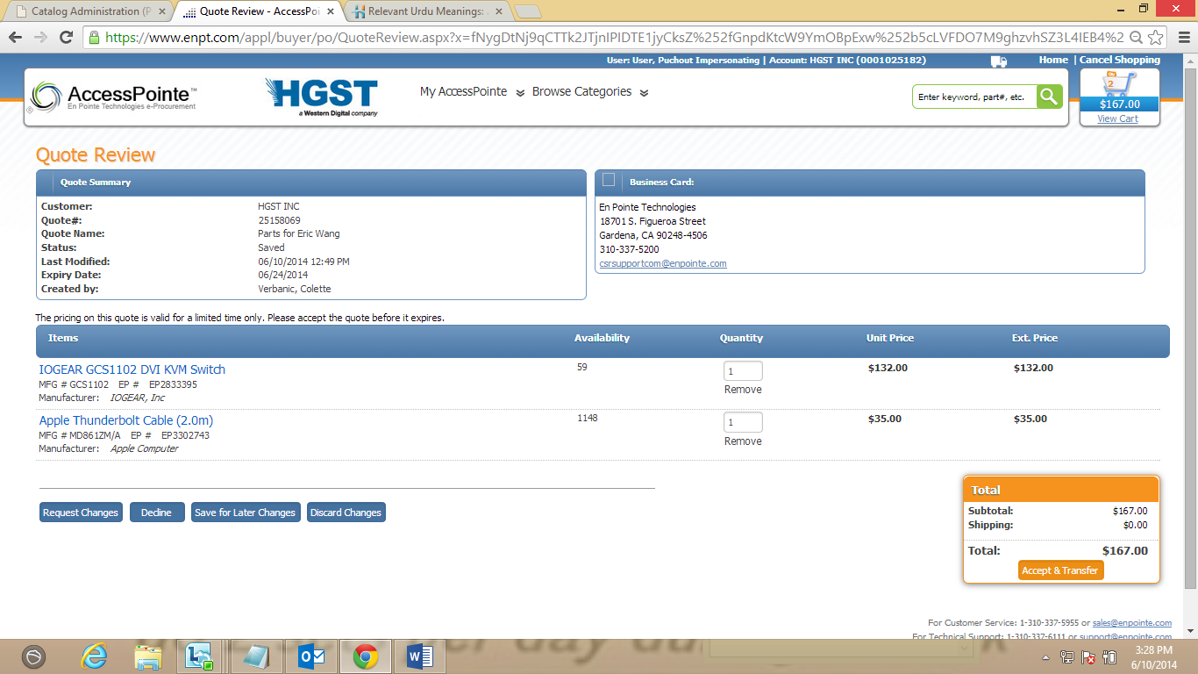
u

Have Questions?

Please contact AccessPointe Support team:
E-Mail: apsupport@enpointe.com
Phone: (310) 337-5200 ext. 2825 for Siraj Khalid

